**Personal Finance Tracker Documentation**

# 1. Introduction

The Personal Finance Tracker is a Windows Forms app made with C# that helps users manage their money easily. It has a simple interface to record, track, and analyze personal finances. The app uses CSV (Comma-Separated Values) files to store data, which keeps things simple and makes the data easy to move and share.

# 2. System Overview and Requirements

The Personal Finance Tracker requires a Windows operating system with .NET Framework installed. The application is lightweight and does not require a significant amount of system resources.

# 3. User Interface and Design

The application's user interface is designed to be intuitive and user-friendly. It includes various controls such as labels, text boxes, combo boxes, date time pickers, and data grid views to facilitate interaction and data management. The responsive design ensures the application looks good and functions well on different screen sizes.

# 4. Functionality Implementation

## Add Transaction

Users can effortlessly record various types of financial transactions, including income, savings, and expenses. Each transaction captures essential details such as the date, description, category, and amount, providing a comprehensive overview of financial activity. All transactions are securely stored in a CSV file, ensuring that users have a centralized repository for their financial data.

## Delete Transaction

Users have the flexibility to remove any unwanted transactions from their records based on unique transaction ID. Upon deletion, the transaction is promptly removed from both the data grid view within the app and the underlying CSV file, maintaining data integrity and organization.

## Update Transaction

Should the need arise, users can easily modify existing transactions to reflect changes or corrections. While certain details such as the transaction ID remain immutable, users have the freedom to update other attributes such as the date, description, category, and amount. Updated transaction seamlessly replaces the original entry in the CSV file, ensuring that the latest information is accurately reflected in the financial records.

## View Transaction

Users can conveniently review the details of any transaction by selecting it from the data grid view within the app. Upon selection, the transaction's information is dynamically loaded into designated labels, providing users with a clear and concise overview of the transaction. From the transaction date and description to the associated category and amount, users can easily access and assess the specifics of each financial transaction.

## Search Transaction

A user can search for transactions based on amount, details, ID, or category. Upon clicking the search button, the application loads the matching results into the data grid view. From the search results displayed in the data grid view, the user can select and view the details of any specific transaction. This feature allows users to quickly find and review transactions that meet specific criteria.

# 5. Event and Exceptions Handling

The app is ready for any surprise glitches. It uses smart methods like catch blocks to handle problems before they cause the app to crash. This way, you can keep using the app without any interruptions or worries. It's like having a safety net that catches any issues before they become big problems, making the app reliable and trustworthy for managing your money.

# 6. Data Validation and Integrity

To maintain data accuracy and completeness, the Personal Finance Tracker incorporates comprehensive data validation mechanisms. Users are restricted to enter accurate information in all required fields, and the application actively verifies inputs to prevent errors or incomplete data entries. In cases where essential information is missing or invalid, message boxes guide users to resolve the issues, ensuring the integrity of financial records.

# 7. Code Structure and Documentation

The code is organized into clear, modular sections, with each function having a specific responsibility. Comprehensive comments and documentation are included to explain the functionality and logic, making the code easier to understand and maintain.

# 8. Additional Features and Improvements

## Unique Transaction ID

The app makes sure every transaction gets a special ID number that's different from the others. This stops any chance of having two transactions with the same ID or mixing up the data. It does this by creating these ID numbers automatically, making it easier to keep track of everything. This way, the app keeps all your financial records organized and accurate.

## Responsive and Attractive UI

The app has a flexible design that adjusts to different screen sizes, making it look good and work well on any device. It changes how things are arranged and makes it easy to move around the app. This makes it easy for everyone to use and adds a bit of fun with buttons that change when you hover over them.

## File Handling

File handling is central to the Personal Finance Tracker, ensuring smooth storage and retrieval of financial data. Transactions are securely stored in CSV files, maintaining organization for easy access. The app employs error-checking to prevent data corruption and ensure accuracy, instilling confidence in users about the reliability of their financial records.

# 9. Testing and Feedback

Extensive testing has been conducted to ensure the application functions correctly. Feedback from users has been incorporated to improve the application's usability and performance.

# 10. Conclusion and Recommendations

The Personal Finance Tracker is a comprehensive solution for managing finances effectively. It offers essential features and a user-friendly interface, empowering users to take control of their financial well-being. Whether tracking daily expenses or planning for the future, this app provides the tools needed for success. With intuitive transaction management and robust error handling, it simplifies financial management and enhances the user experience. From setting budgets to achieving financial goals, the Personal Finance Tracker is your go-to tool for smart money management.

# 11. Appendices

The appendices include wireframes and additional resources for further reference.

The wireframes provided illustrate the user interface design for key functionalities including adding, deleting, updating, and searching transactions, offering users a visual representation of the application's layout and workflow.

## Main Menu:

The main menu wireframe presents users with two primary options: "Manage Transactions" and "Exit." Upon selecting "Manage Transactions," users are directed to the transaction management menu, where they can perform various tasks related to financial transactions. The "Exit" button gracefully handles application closure by first saving data to the file and then terminating the application, ensuring data integrity and user convenience.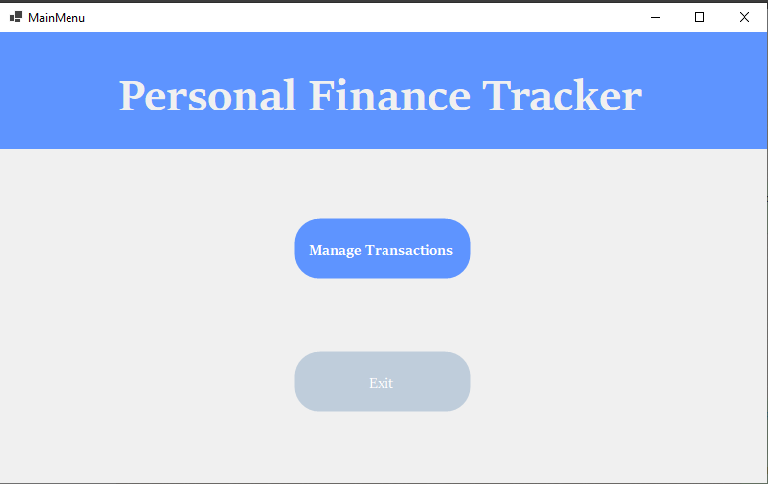

Fig 1: Main Menu

## Add Transaction:

The "Add Transaction" page has easy-to-use boxes where you can type in details like date, description, and amount. Once you're done, just hit the "Add Transaction" button. The app will check if everything's filled in correctly. If it is, it'll give your transaction a special number, save it to your file, and show a message saying it worked. Then, it'll update the page so you can see your new transaction.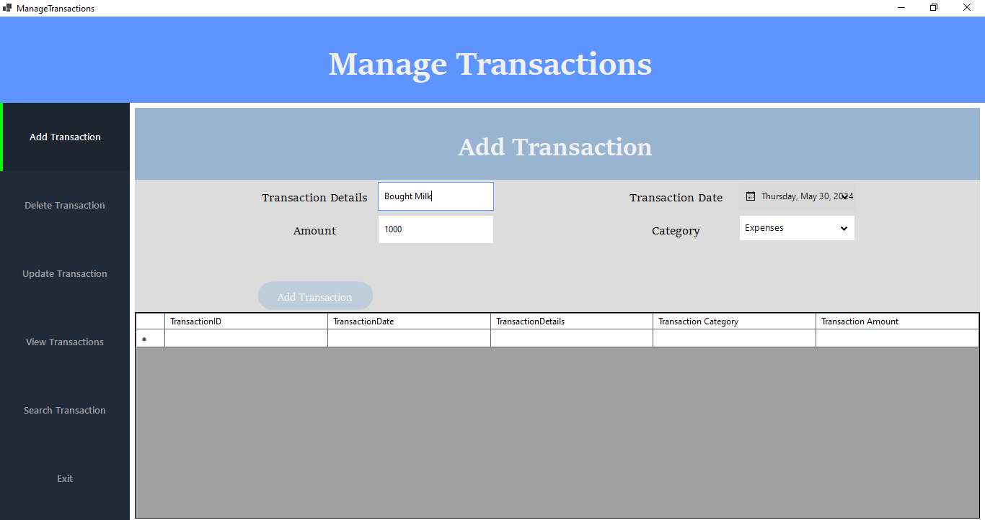

Fig 2: Add Transaction

## Delete Transaction:

The "Delete Transaction" section shows nine labels, a date picker, and a list of transactions. When you pick one from the list and press "Delete," it removes that transaction from both the list and your records. Afterwards, you'll get a message saying it's been deleted successfully. But if you forget to pick a transaction before pressing "Delete," it'll remind you to choose one first.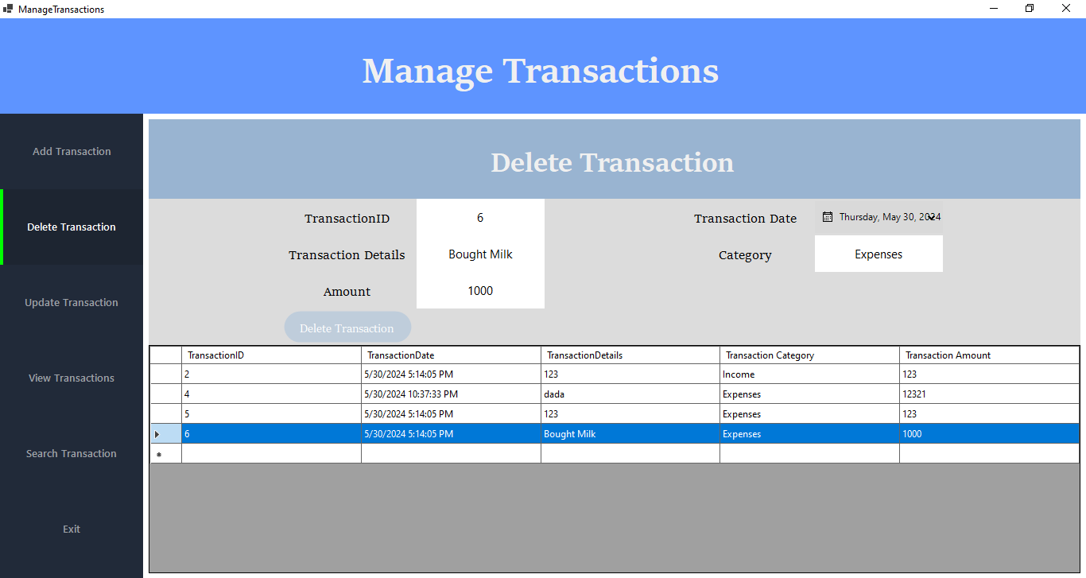

Fig 3: Delete Transaction

## Update Transaction:

In the "Update Transaction" section, you'll find six labels, a calendar tool, two boxes where you can type in information, a drop-down menu, and a list of transactions. When you pick one from the list and hit "Update," it loads the details of that transaction into the boxes. You can then change any of the information, like the date or amount. After you're done, click "Update" again, and the app will check to make sure everything's okay. If it is, it'll save the new information in your file and refresh the list so you can see the changes.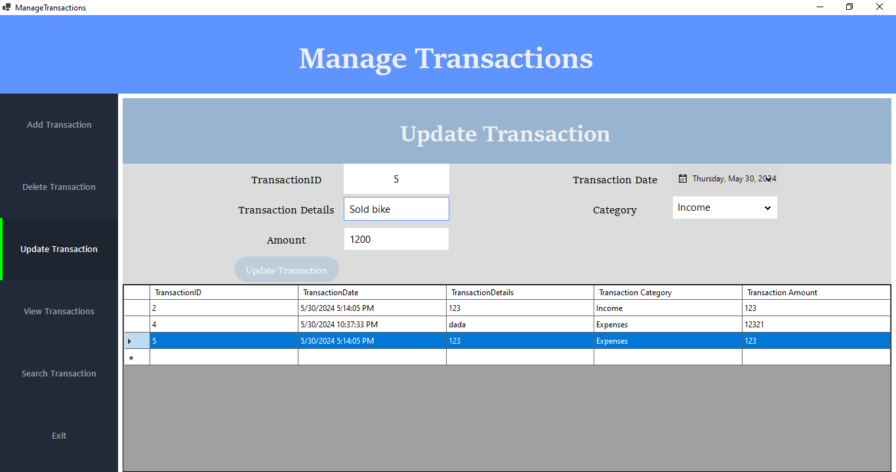

Fig 4: Update Transaction

## Search Transaction:

In the "Search Transaction" section, there are nine labels, a calendar tool, a box where you can type in what you're looking for, and a drop-down menu. You put in the details you want to find in the box and choose from the drop-down menu what aspect of the transaction you're searching for, like the date or the amount. When you hit "Search" the app checks through your file for matches and shows them in a list. If you click on one of the transactions in the list, it'll load all the details into the labels so you can see everything about that transaction. This helps you get a good overview of the information you're looking for.

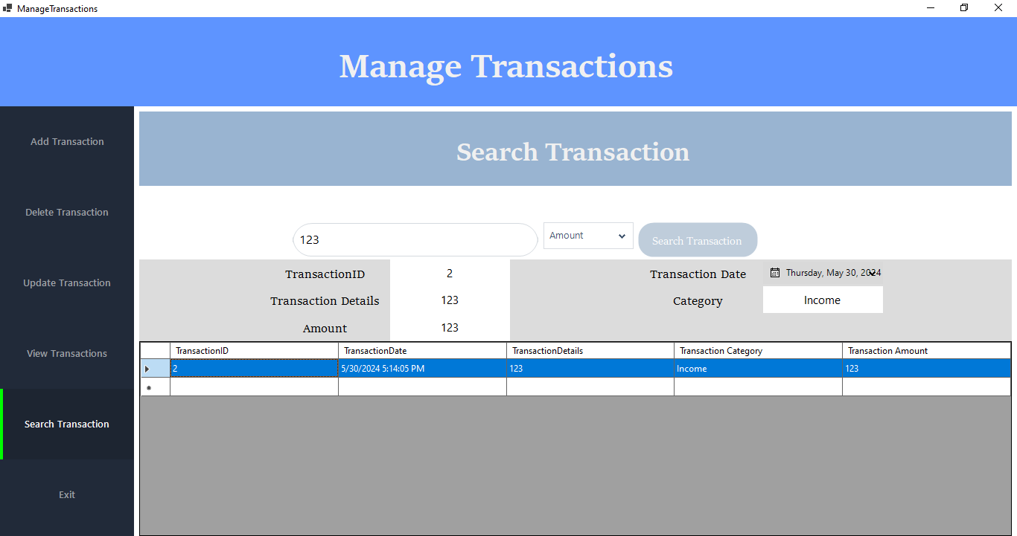

Fig 5: Search Transaction